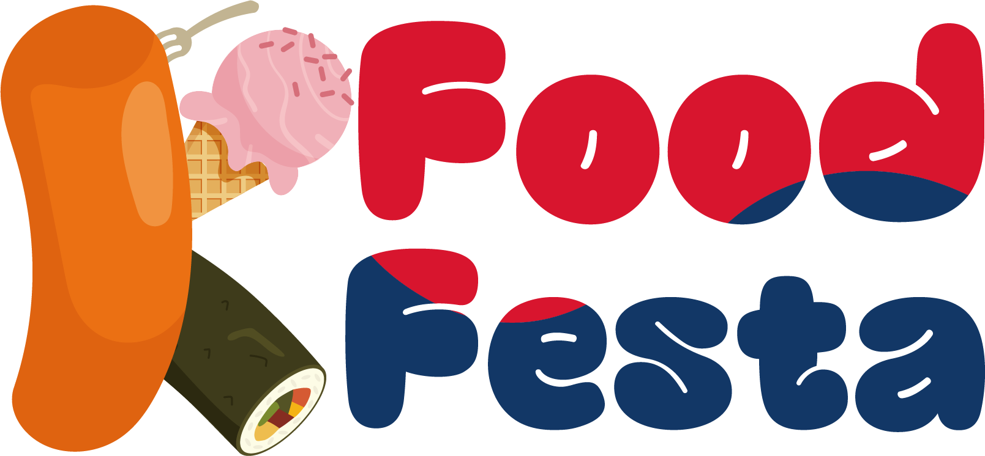 | K-Food Festa in Seoul 2024
Participation Form

1. Participant
Closing Date : 31, May, 2024
*Please, read the exhibition regulations carefully before filling out the form
Name of Sign
Name of Company
Website
Address
Country |  | City |  |  | Zip code |  |  | Contact No. | (Country Code) -
Representative |  |  |  |  |  |  |  | Fax
Person in charge |  | (Exhibitor) |  |  | Cell phone |  |  | E-mail
Exhibition Items  (Please check in the box) |  | Handmade Food |  | ☐Handmade Dessert ☐Handmade Snacks ☐Fruit Tea ☐Others( )
 |  | Sauce |  | ☐Seasoning ☐Spice ☐Sweetener ☐Marinade ☐Salted Seafood ☐Others( )
 |  | Dessert |  | ☐Chocolates ☐Bakery ☐Crackers ☐Cookies ☐Biscuits ☐Ice creme  ☐Jelly ☐Flower Cake ☐Pudding ☐Ice Flakes ☐Others( )
 |  | HMR |  | ☐Meal kit ☐Retort Pouch ☐Instant Food ☐Frozen Food ☐Fresh-cut Food ☐Others( )
 |  | Street Food |  | ☐Tteok-bokki ☐Gimbap ☐Fried Food ☐Skewers ☐Noodles ☐Others( )
 |  | World Food |  | ☐Western Food ☐Chines Food ☐Japanese Food ☐Vietnamese Food  ☐Halal Food ☐Indian Food ☐Others( )
 |  | Drinks |  | ☐Ade ☐Tea ☐Coffee ☐Soft Drinks ☐Alcoholic beverages ☐Juice ☐Smoothie  ☐Milkshake ☐Others( )
 |  | Dairy Products |  | ☐Milk ☐Yogurt ☐Cheese ☐Butter ☐Cream ☐Others( )
 |  | Health Functional  &Organic Food |  | ☐Health Functional Food ☐Diet Food ☐Nutritional Supplement ☐Food Therapy  ☐Organic Food ☐Others( )
 |  | Baby Meal |  | ☐Weaning Food ☐Powdered Milk ☐Baby Snack ☐Baby Drink  ☐Side dishes for Baby ☐Others( )
 |  | Food Related Industry |  | ☐Services/Platform ☐Startup/Foundation ☐Electronics ☐Kitchen Appliances  ☐Food Appliances ☐Accessories ☐Others( )
 |  | Others |  | ☐Processed Food ☐Food Ingredients/Supplies ☐Others( )
 |  | ※ Details of exhibition items

2. Application for Exhibition Space
Booth Type | Unit Price(USD) | Dimensions  (Meter: W x D x H) | No. of Booth(s) |  | Sub-Total
Market Booth | USD 400 | 2.0m X 2.0m | Booth(s) |  | USD
Standard Shell A | USD 700 | 2.0m X 2.0m X 2.8m | Booth(s) |  | USD
Standard Shell B | USD 1,300 | 3.0m x 3.0m x 2.8m | Booth(s) |  | USD
Raw Space | USD 1,100 | 3.0m x 2.0m | Booth(s) | USD
※ Market Booth: 1 Information desk, 1 Chair and 1 Socket are provided. (No Wall, Only Area is provided)
※ Raw Space: Organizer provides only exhibition space, should be applied more than 2-booth.
※ Provided supplies may vary depending on booth type. Please visit our website for more information. (k-foodfesta.com).
※ Design of Booth
Market Booth | Standard Shell A | Standard Shell B
 |  | 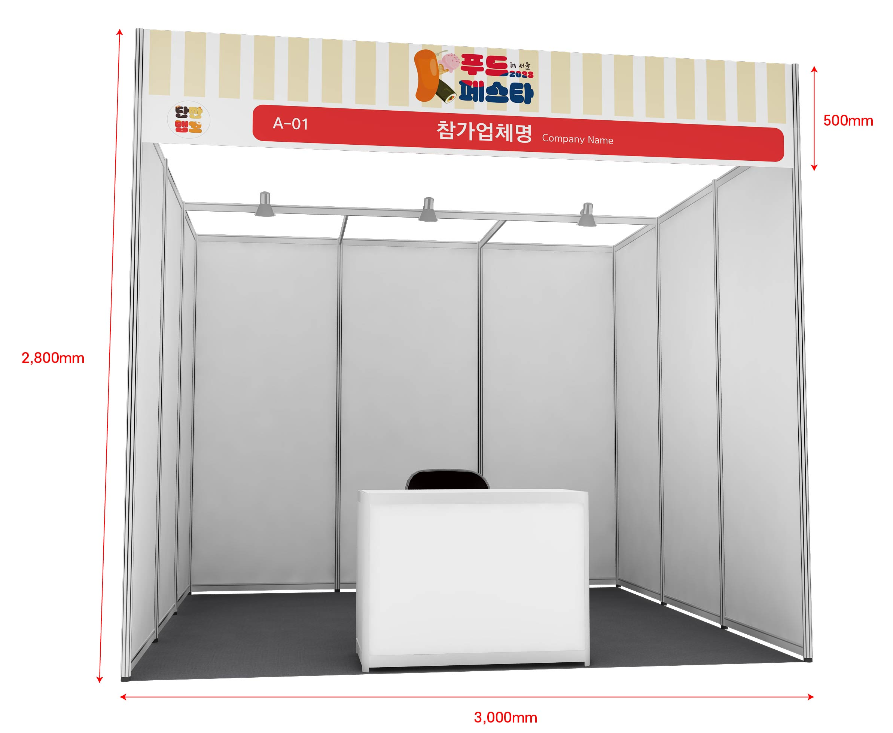
3. Additional Facilities
Category |  | Cost | Requirement | Total Cost
Telephone | Domestic | USD 80 | 0 Line(s) | USD
 | International | USD 150 | 0 Line(s) | USD
Electricity | Daytime | USD 50 | 0 Kw | USD
 | 24Hours | USD 60 | 0 Kw | USD
Water drainage |  | USD 200 | 0 Unit(s) | USD
Compressed air |  | USD 200 | 0 Unit(s) | USD
Internet Line(LAN) |  | USD 150 | 0 Port(s) | USD
Information Desk |  | USD 30 | 0 ea | USD
Chair |  | USD 10 | 0 ea | USD

3. Participation Fee in Total: USD___________________________________
I, hereby, confirm that I will follow the rules & regulations of ‘K-Food Festa in Seoul 2024’ and that I have enclosed a payment (50% of the participation fee) and a copy of the payment remittance.

/ /
DD/MM/YY |  | Name of Applicant (Representative) |  | (Signature)

■ How to save your money when trying to rent a booth
• Early bird booking discount: 20% - discount (only for those participants who pay in a down payment after submitting the application form by March 29th, 2024)
• Previous Participants: 5% (who have participated this fair before)
※ Maximum discount rate : 25%

■ Please, make the deposit to;
• Bank: Shinhan Bank • Account No.: 180-006-181212 • Beneficiary: Korea Int'l Exhibition co., LTD
• Swift Code: SHBKKRSE • Address: 57, yeouinaru-ro, yeongdeungpo-gu, Seoul (Yeouido-dong)

■ How to Apply; Tel: 82-2-761-2514 | Fax: 82-2-761-2517 | Email: info@k-foodfesta.com
Address: No. 1116, (Yeouido-dong), 33, Gukjegeumyung-ro 6-gil, Yeongdeungpo-gu, Seoul

The Rules & Regulations of K-Food Festa in Seoul 2024

Article 1 Definition
1. "Exhibition" refers to ‘K-Food Festa in Seoul 2024’.
2. "Organizer" refers to ‘K-Food Festa Organizer Office’
3. "Exhibitor" refers to individual, company, organization or group applied for the participation in this exhibition.

Article 2 Exhibition application and agreement
1. The one who wish to participate in the exhibition shall fill the application form, receive approval from the organizer and pay 50% of the total participation fee by bank transfer within 7 days.
2. After submitting the application form, if the organizer refuses to approve for harmonious constitution and operation of the exhibition, the agreement will not be effective.
3. Participation fee is;
Booth Type | Unit Price | Booth Type | Unit Price
Market Booth | USD 400 | Standard A | USD 700
Standard B | USD 1,300 | Raw Space | USD 1,100
4. Technical support and standard package construction will be provided by the organizer upon the request of the exhibitor. In case of any alternation in technical support request, the exhibitor shall inform the organizer in prompt manner. Any disadvantage occurred by the non-inform is subject to the exhibitor’s responsibility.
5. The exhibitor shall display only the items specified in the application form, and if the signboards, business names, items, etc. differ from the details of the application on the day of the exhibition, the organizer may remove the relevant business from the site.
6. Method of Payment
· Bank: Shinhan Bank
· Account No.: 180-006-181212
· Beneficiary: Korea Int'l Exhibition co., LTD
· Swift Code: SHBKKRSE

Article 3 Assignment of Exhibition Booth
1. Organizer has all rights to the booth assignment and Exhibitor may not object to the decision made. According to application and payment order, booth will be assigned considering country, item, size, exhibition results and other reasonable matters.
2. The organizer may change the allocated booth location in case the organizer acknowledges the necessity considering spacing harmony, viewing efficiency and exhibition effectiveness. Such change is under discretion of the organizer, and the exhibitor shall not object on the decision.

Article 4 Exhibition Management
1. Exhibitor shall display the items listed in the application and have someone to take care of the booth at all times.
2. If the Exhibitor displays items not listed in the application or if displayed item does not fit the nature of the exhibition or conducts direct sales without approval from the Organizer, Organizer can request to stop, withdrawal or dismantle. This case, participation fee is not refundable and Exhibitor may not ask for compensation.
3. Organizer may prohibit certain people from the exhibition, if necessary.
4. Exhibitor cannot use other area for the exhibit without prior approval from Organizer.
5. Exhibitor cannot use speaker or amplifier without prior approval Organizer and sales or loud activities are strictly prohibited.
6. For any damages that cannot be returned into original state, such as painting the floor/ceiling/wall, Exhibitor is liable for any reasonable compensation requested by Organizer regarding the restoration.

Article 5 Payment
1. Exhibitor shall make an initial payment of 50% of the total participation fee when submitting application and the balance shall be made before May. 31(Fri.) 2024. When submitting the application after May. 31(Fri.) 2024, 100% of the participation fee shall be paid when submitting application.
2. In the event of Exhibitor not making the balance payment within the designated deadline, organizer may cancel the contract and the Exhibitor cannot ask for refund. The matter will be resolved according to Article 6 of this Rules and Regulation.

Article 6 Termination of the Agreement (Exhibition Cancellation) and Penalty
1. The Exhibitor cannot assign the contract, sub-let or part with his site or stand or any portion of it without prior written consent from the Organizer. If the Exhibitor breaches this term, exhibition can be cancelled and the fee will not be subject to refund.
2. If the Exhibitor does not pay the participation fee within the designated period, 14days notice will be given to him/her to make the payment and still if the payment is not made, Organizer has the right to cancel the exhibition contract. In this case, Exhibitor is not entitled to refund.
3. In case the exhibitor cancels or refuses the whole or partial space which is already registered due to own reason, the exhibitor shall inform the organizer in document and pay the penalty that is settled below within 14 days. Penalty is deducted from the paid participation fee, if not sufficient, the exhibitor shall pay the addition, and if surplus, the balance will be returned.
* Cancellation Penalty
- Prior to 31th, May, 2024 : 50% of participation fee
- From 31th, May, 2024 to 30st June, 2024 : 80% of participation fee
- After 1st, July, 2024 : 100% of participation fee

Article 7 Cancellation of Exhibition or Alteration
In the event of cancellation or date change of the exhibition due to irresistible force or other causes not resulting from the Organizer, already paid exhibition fee will not be refunded and Exhibitor may not ask for compensation.

Article 8 Display of items
1. Exhibitor shall complete installment, entrance and display of the item within the designated date. In case of items not being displayed until 8 pm, July 18(Thur.), 2024, Organizer has the right to temporarily cancel that exhibition and ask for compensation.
2. Exhibitor can use their own space given by Organizer for the display of their items only from opening time to 8 p.m on designated date. If additional working hour is required, additional work application shall be submitted and extra charge shall be made.

Article 9 Restoration
1. Exhibitor shall observe the opening and closing time, and all disadvantages arising from violation of this rule shall be the responsibility of the participant.
2. After the exhibition (21th(Sun), July, 2024, 6pm-), Exhibitor shall restore booth space to the original state as fast as it possible. Exhibitor is liable for any expenses/losses, including additional charge caused by delay, arising to the Organizer from a delay of dismantling.

Article 10 Security and Safety
1. Organizer shall take proper action (aT Center’s exhibition regulation) to secure safety for the Exhibitor and visitors.
2. Exhibitor is fully liable for any damages or loss occurred during the exhibition preparation period, exhibition period and dismantling period.
3. If Exhibitor intently caused fire, damage, loss or other accidents causing loss to Organizer or any 3rd party, Exhibitor is fully liable for the cause and insurance regarding all materials and items.

Article 11 Fire Safety
1. All materials and items must be fire resistant according to the safety regulations.
2. Organizer may ask for modification regarding fire prevention to the Exhibitor if necessary.

Article 12 Amendment
1. The Organizer reserves the rights to modify at any time the provisions of the present Rules & Regulation; the Exhibitors shall comply with the modification.
2. The Exhibitors must comply with the regulations of aT Center.

Article 13 Disputes
In any disputes that may arise concerning interpretation of the present Rules & Regulations, the Exhibitor agree to the competence of the Commercial Arbitration Rules of the Korean Commercial Arbitration Board and shall not bring a law-suit against the ruling.

